Dokshitsky region

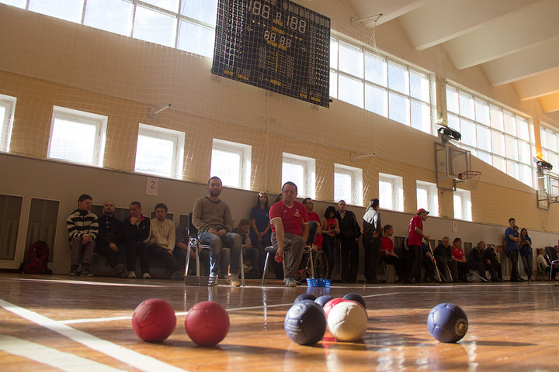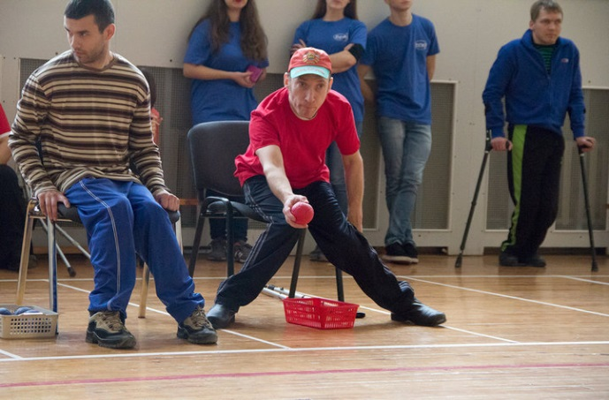

1.Project title: PE, Activity and Sport – all that make the children strong!
2.Project implementation period: 6 months from the beginning of the project implementation.
3.The applicant that proposed the project: the Sector of sport and tourism of the Dokshitsy district Executive Committee.
4.Objectives of the project:
1.strengthening health and improving the psychological state of families in which children with disabilities are brought up.
5.Tasks planned for implementation in the framework of the project: 1.to organize healthy leisure and the ability to lead an active lifestyle;
2.create conditions for overcoming the social isolation of children with disabilities;
3.develop communication skills;
4.To educate in society tolerant attitude towards children with disabilities and their families.
6.Target group: children with disabilities and their families.
7.A brief description of the activities within the project: conducting competitive multisport games in Dokshitsy: acquiring large sets for playing bowls – “Bocce”; equipping the playground for playing bowls – “Bocce”; purchasing play sets “Small towns”; purchasing children’s bowling kits, purchasing mini basketball stands, purchasing darts sets, purchasing premium products, media coverage (publishing at least three articles on the progress of the project), conducting training sessions with children – people with disabilities and their families, payment for the services of an expert-social teacher, payment for the services of an expert psychologist.
8.Total amount of financing (in US dollars): 11.000
Source of funding | Amount of funding  (in US dollars)
Donor funds | 10.300
Co-financing | 700
9.Location of the project (region/district/city): Vitebsk region, Dokshitsy
10.Contact person: E.S. Rachitskaya, sector inspector, 8(02157)2-52-31, +375(29) 591-99-89, doksport@vitobl.by

We look forward to collaborating!

